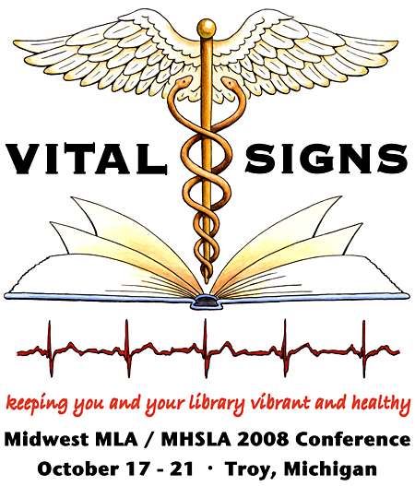

MHSLA
2008 Conference Planning Committee Report

Midwest MLA / MHSLA 2008 Conference
October 17 – 21, 2008 at the Detroit Marriott - Troy

11/13/08

After almost 3 years of planning, the 2008 joint Midwest / MHSLA Conference “Vital Signs: Keeping You and Your Library Vibrant and Healthy” has been completed.

The conference offered three days of continuing education with 9 course offerings and two days of conference programming. The keynote speaker was Deena Ebbert, presenting the FISH! Leadership Philosophy, and the plenary speaker was MJ Tooey, Executive Director of the Health Science and Human Services Library at the University of Maryland and former MLA President.

There was a Motown themed welcome reception and a special event at the newly renovated and impressive Detroit Institute of Arts.

The exhibit committee did a great job and attracted 26 paid exhibitors. There were 19 posters for the poster session and 15 contributed papers, as well as several concurrent sessions and a Tech Forum.

The original plenary speaker, Eugenie Prime, had to withdraw due to health issues. M.J. Tooey agreed to fill in as plenary speaker. A couple of other speakers / instructors had to withdraw, but were able to provide substitutes.

Paid registrations and CE participants as of 11/13/08 (the numbers below do not include the 25 exhibitor registrants whose registration was part of their booth fee):

Full Registrations 126
One day only 20
Student 9
CE only 13

Total 168 Total Registration income $37,200

There were 74 MHSLA member registrants, 90 Midwest member registrants and 15 that indicated no affiliation.

CE participants
8 hour 52
3- 4 hour 55

Total 107 Total CE income $14,930

There were 26 paid exhibitors (one, NEJM, was a donation only), and three Sunrise Seminars (Ebsco, Elsevier, and Ovid).

Total Exhibitor income: $25,145

We had guaranteed 450 room nights (negotiated down twice) and had a 10% hedge factor, so we were liable for 405 room nights. The hotel gave us credit for 351 room nights (we actually used less - approximately 320). We paid $6426 for room attrition.

The room nights may have been adversely affected by a problem with reserving double rooms. In August the hotel was indicating that there were no double rooms available. This problem was worked out, but the solution was somewhat cumbersome, and we may have lost some registrants because of the confusion.

Conference evaluations were very good overall. The return rate was excellent (110 as of 11/12/08). We would recommend using an electronic survey again in the future. A summary of the MHSLA specific evaluation is attached.

The conference had an overall profit of $2628.05, which was split between Midwest MLA and MHSLA.

Respectfully submitted,

Ellen O’Donnell, Conference Coordinator
Sandra Martin, Local Arrangements Chair

